Gabriel Martinez
WES 267B
Assignment 4

Assignment 4 Report

4.1 blas_mm Lab
Measurement | Assignment #2 | Assignment #3 | Assignment #4 (B=1) | Assignment #4  (B=1,)
Real time | 0m32.536s | 0m4.310s | 0m10.440s | 0m9.970s
User time | 0m32.176s | 0m2.258s | 0m9.183s | 0m8.718s
System time | 0m0.225s | 0m0.785s | 0m0.700s | 0m0.890s
The table below highlights the lab results obtained by running the `time make run` command.

Measurement | 3.1 OpenCL Naïve MM | 3.2 OpenCL Tiled MM | 3.3 Neon Block MM (256x256 Block)
Real time | 0m 50.718s | 0m4.310s | 0m24.954s
User time | 0m 2.154s | 0m2.258s | 0m24.512s
System time | 0m 0.755s | 0m0.785s | 0m0.323s

Measurement | 2.1 Naïve MM | 2.2 Block MM | 2.3 Block MM Unrolled
Real time | 1m15.191s | 0m34.149s | 0m32.536s
User time | 1m14.574s | 0m33.819s | 0m32.176s
System time | 0m0.336s | 0m0.215s | 0m0.225s

 | Speedup (x)
Assignment #2 | 15.72
Assignment #3 | 4.54

* Please use the `time` command to compare this against your implementations in
Assignment 2 and 3. Is this faster for all matricies? If not, why?
Answer: Assignment #4 achieved a 3.12x speedup over Assignment #2. However, Assignment #3's OpenCL Tiled MM was 2.42x faster than Assignment #4. Therefore, Assignment #4 was not faster than all previous implementations. The OpenCL tiled implementation was likely faster because it was specifically optimized for the tested matrix sizes and the Qualcomm Adreno 643 GPU. In comparison, CLBlast uses a more general implementation that was not specifically tuned for the Qualcomm Adreno 643 GPU. Since, the batch size was one, there was no performance benefit from the batched execution so that likely explains why it wasn’t the fastest all around.

Lab Output (`time make run`)
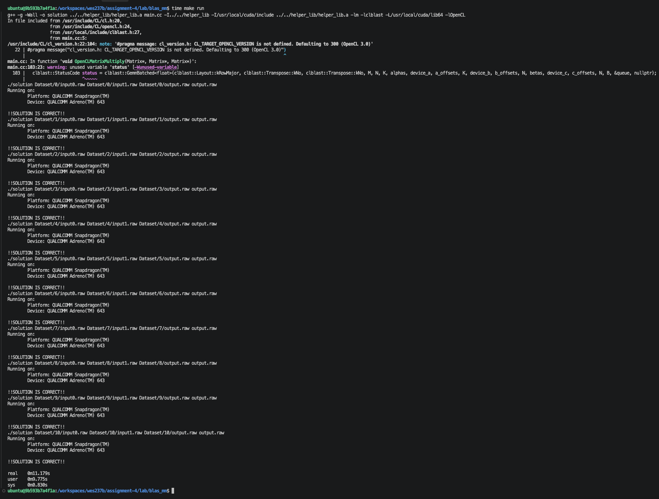

Lab Output (`make benchmark`)
I modified the Makefile to run `time` for each dataset folder.
Assignment 4 | Assignment 3 | Assignment 2
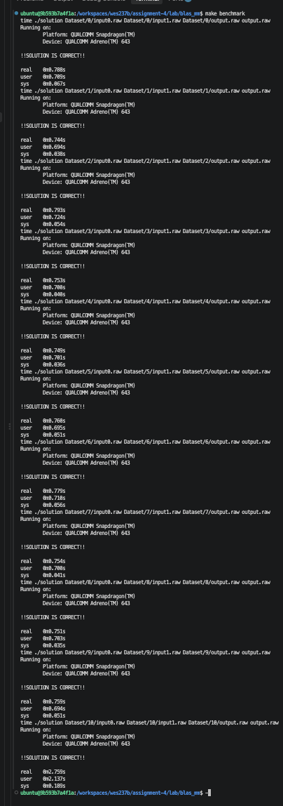 | 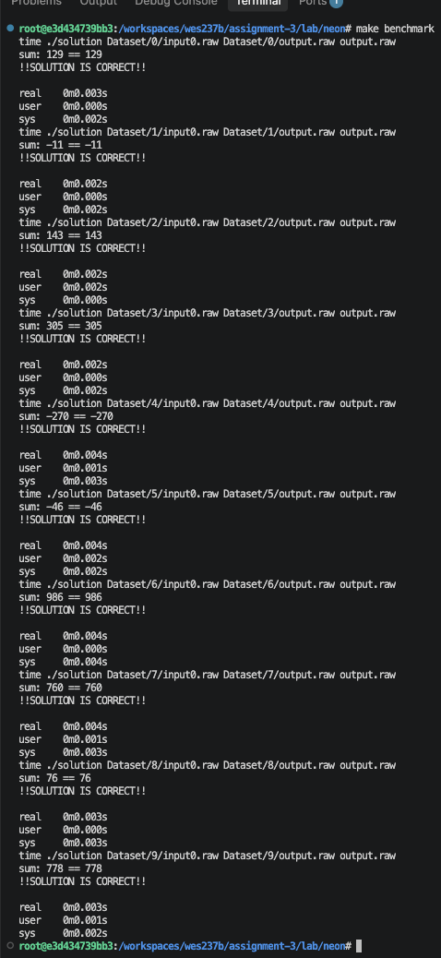 | 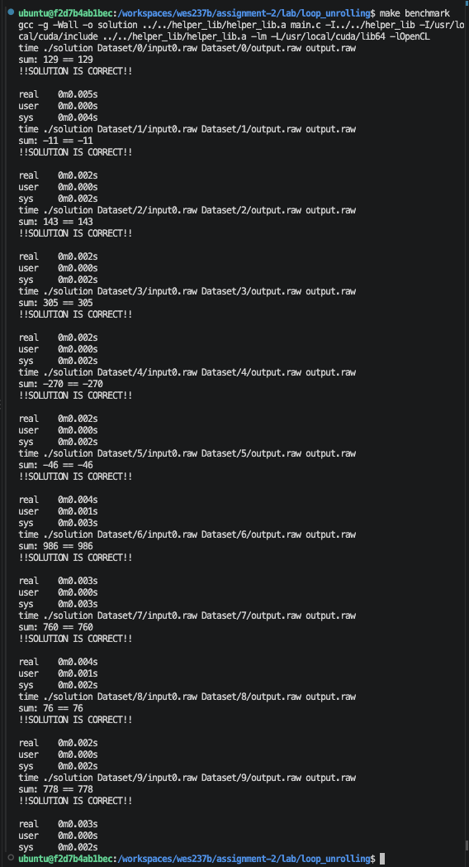

4.2 convolution-2d Lab Report
Describe how you implemented the convolution operation, any optimizations you made, and the performance characteristics of your solution.
I implemented the 2D convolution using OpenCL, where each GPU work-item computes one output pixel for one image channel. The kernel applies the mask over the input image using the specified stride and performs VALID convolution i.e. ensuring that the filter mask remains completely within the boundaries of the 2D matrix.
For optimization, I tested various local work group sizes (see chart below). The global work size is padded to a multiple of the local size, with bounds checking for extra work items. This was needed for the autograder. Otherwise, hardcoding the local work size to be a static number was passing test locally but failed running on the autograder. I also created a new kernel opencl file that explicitly used the local variable ensuring shared memory instead of pulling from the global memory for each convolution multiplication (see results titled shared memory.)

4.2 convolution-2d Lab Output (Global)
Measurement | 4.2 convolution-2d
Local work size | 4x4x1 | 8x8x1 | 16x16x1 | 32x32x1
Real time | 0m7.103s | 0m6.876s | 0m6.999s | 0m6.879s
User time | 0m4.571s | 0m4.570s | 0m4.622s | 0m4.602s
System time | 0m0.774s | 0m0.739s | 0m0.719s | 0m0.752s

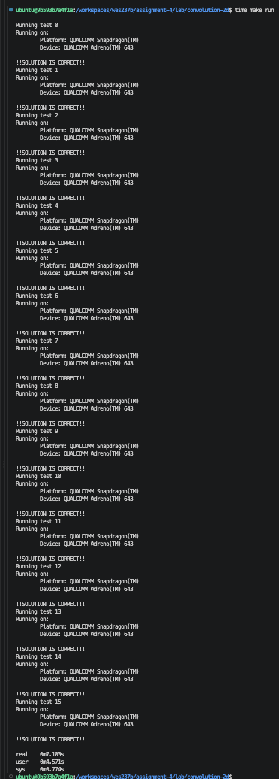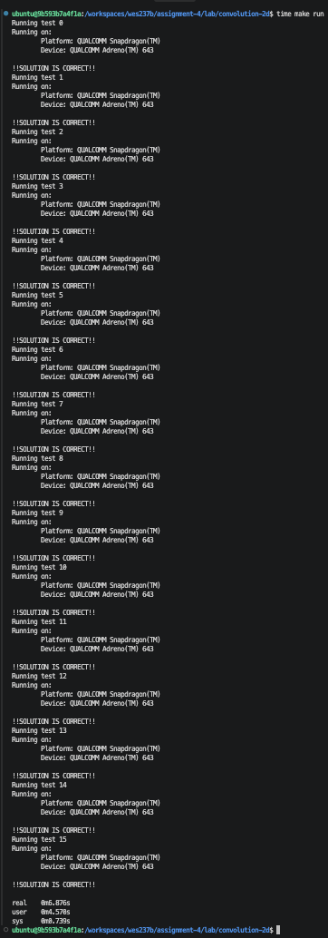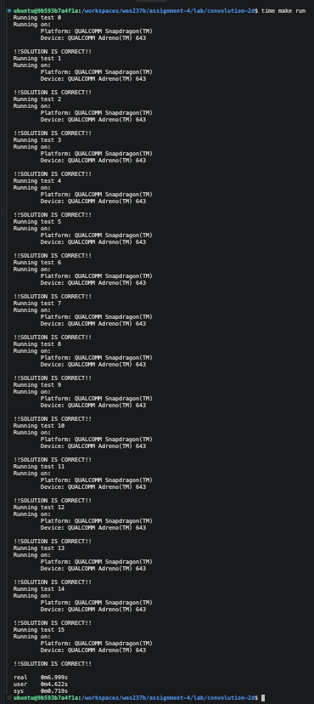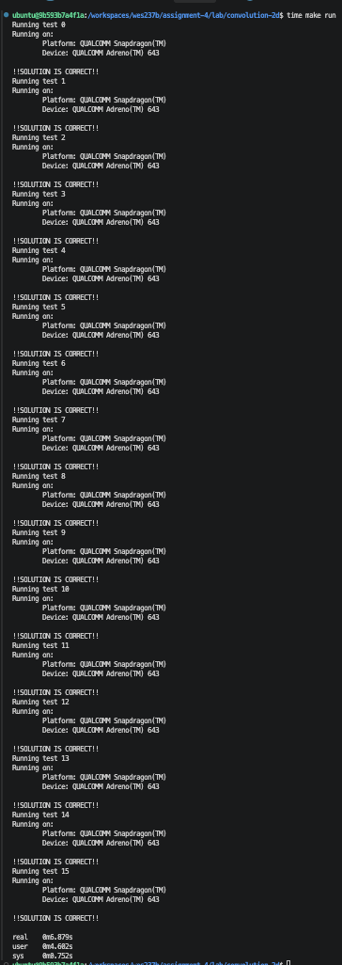
From left to right global shared memory4x4x1, 8x8x1, 16x16x1, 32x32x1

4.2 convolution-2d Lab Output (Shared Memory)
I created a kernel opencl file to use local variable to ensure shared memory instead of pulling from the global memory for each convolution multiplication. The main issue is doing this way requires the use of barrier(CLK_LOCAL_MEM_FENCE) which is needed to ensure all work-items in the work-group have completed their local memory writes before any work-item begins using that shared data for the convolution calculations.
The tile size is dynamically determined using the below:
size_t tileWidth = (localWorkSize[0] - 1) * stride + maskWidth;
size_t tileHeight = (localWorkSize[1] - 1) * stride + maskWidth;
size_t tileSize = tileWidth * tileHeight;

Measurement | 4.2 convolution-2d
Local work size | 4x4x1 | 8x8x1 | 16x16x1 | 32x32x1
Real time | 0m7.572s | 0m6.397s | 0m7.114s | 0m7.177s
User time | 0m4.698s | 0m4.717s | 0m4.795s | 0m4.826s
System time | 0m0.778s | 0m0.734s | 0m0.710s | 0m0.756s
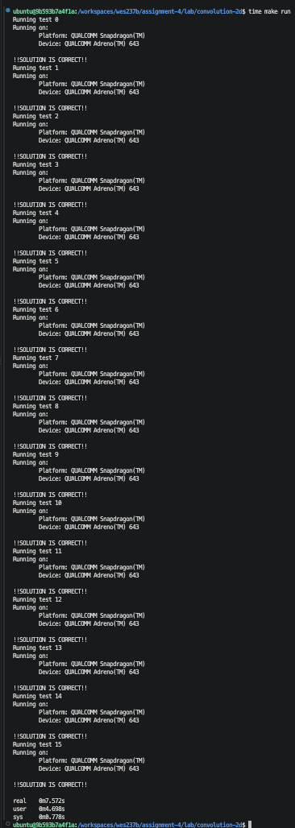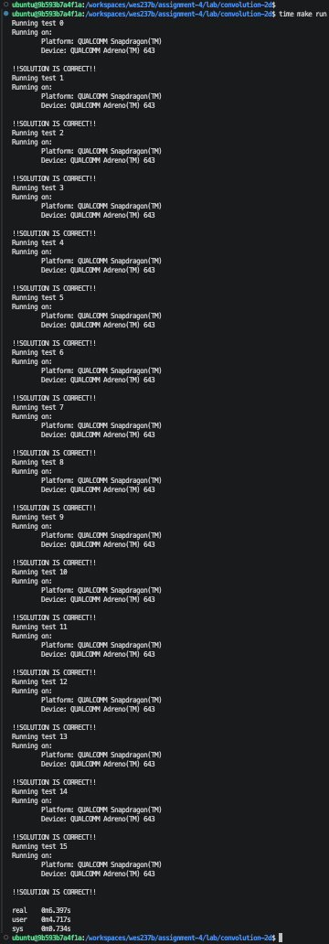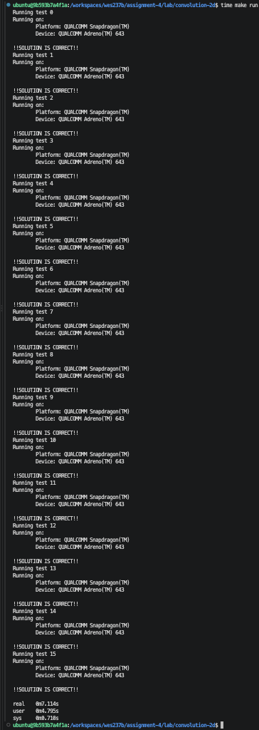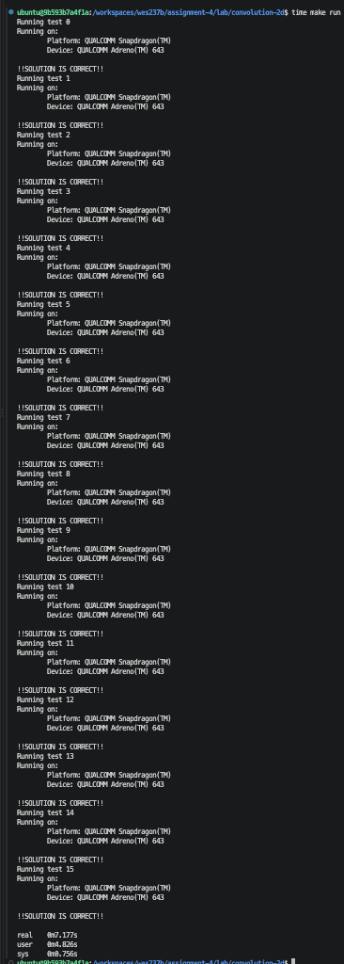
From left to right 4x4x1, 8x8x1, 16x16x1, 32x32x1
I optimized the convolution using tiled local memory. Each work-group tested loads the input tile into local memory, allowing the work-items to reuse the data instead of repeatedly accessing global memory. This improves the efficiency of the convolution kernel. However, the overall application runtime showed little improvement.

4.2.2 With strides output (global shared memory)
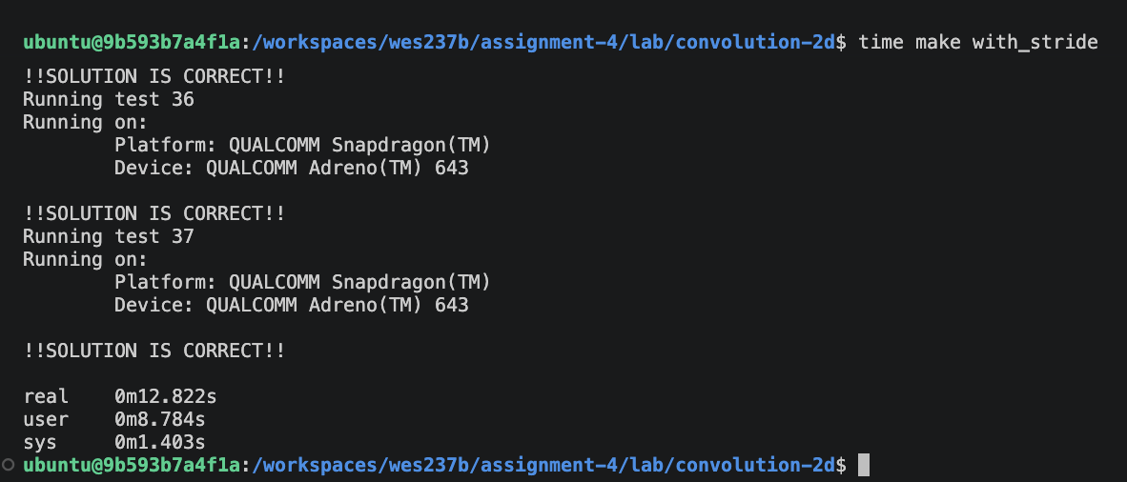
Global shared memory 4x4x1
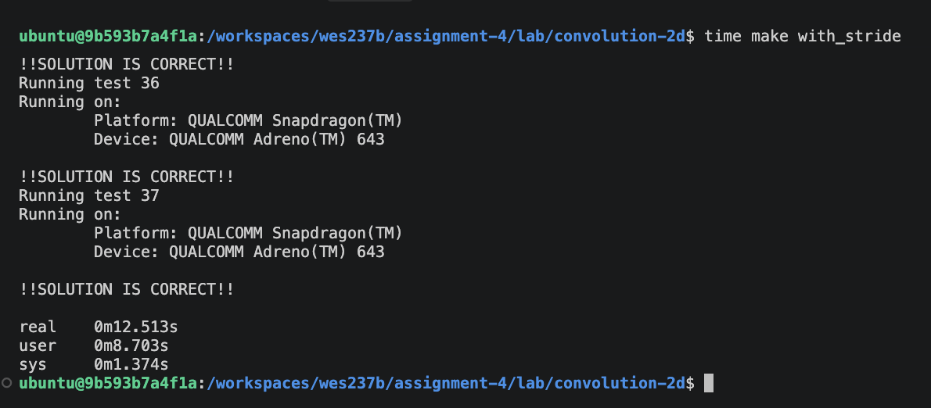
Global shared memory 8x8x1
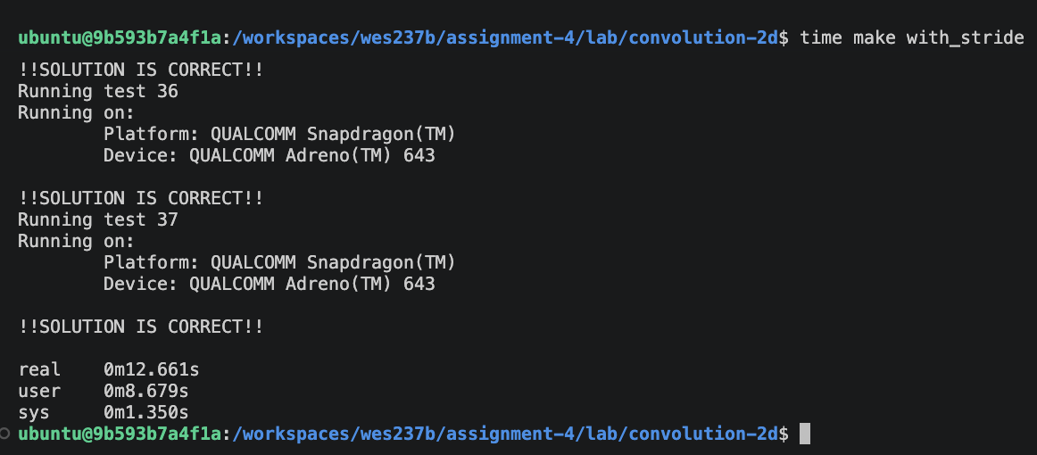
Global shared memory 16x16x1

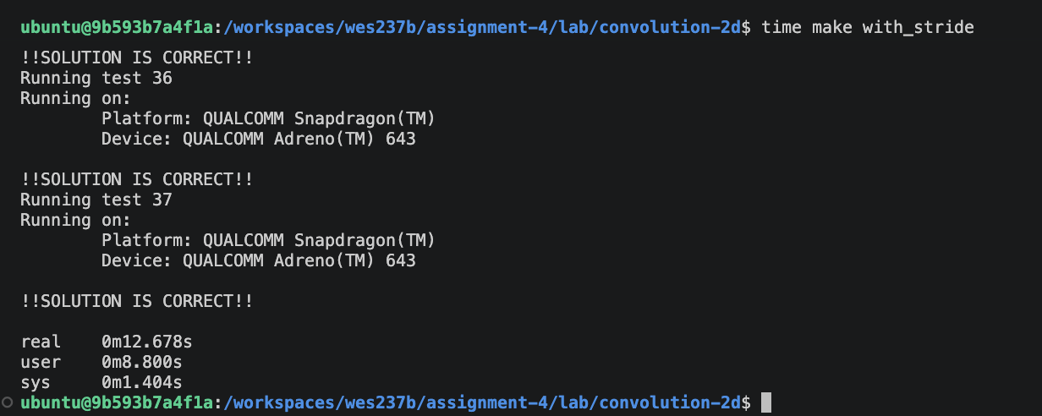
Global shared memory 32x32x1

4.2.3 With strides (local memory)
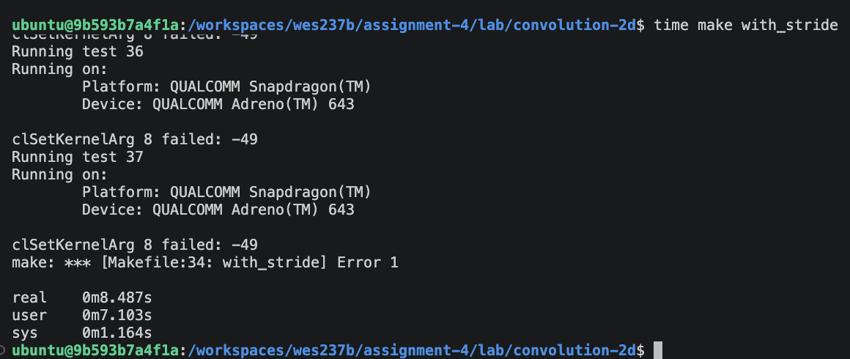
Local memory 4x4x1
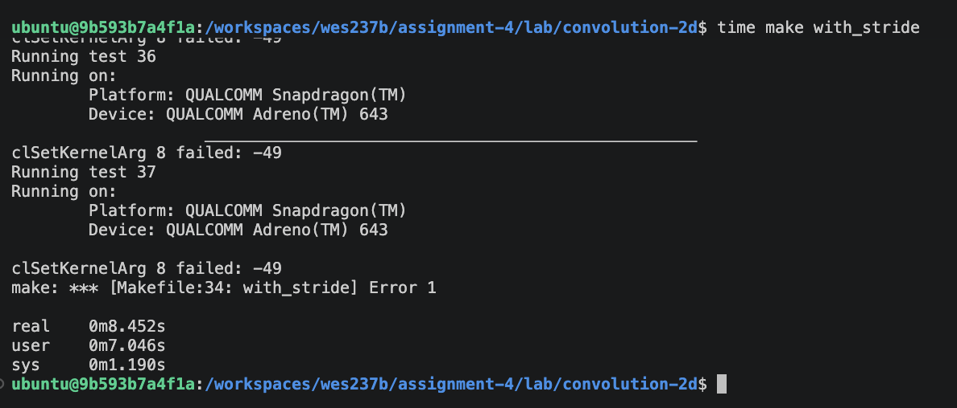
Local memory 8x8x1
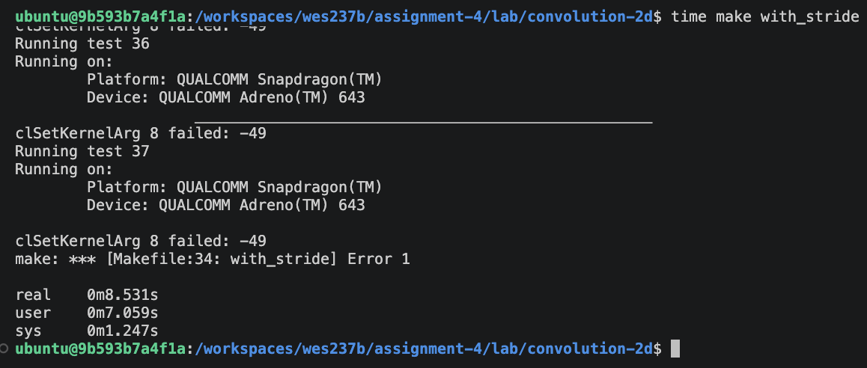
Local memory 16x16x1

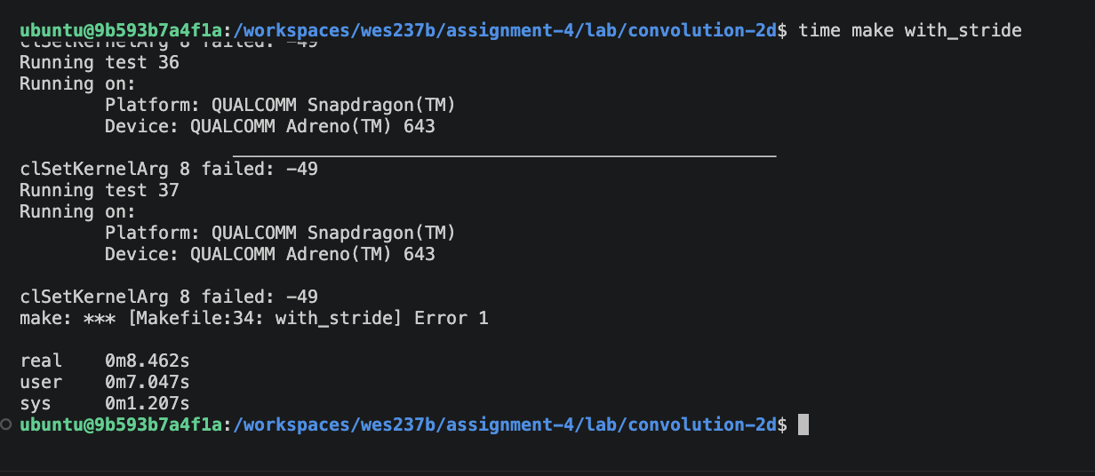
Local memory 32x32x1

4.3 Homework CNN Output

